Ground Water & Seepage   
Aquifers, Porosity, and Darcy’s Law

❖ All water beneath the land surface is referred to as underground water (or  
subsurface water). The equivalent term for water on the land surface is surface  
water.  
❖ Underground water occurs in two different zones. One zone, which occurs  
immediately below the land surface in most areas, contains both water and air and  
is referred to as the unsaturated zone.  
❖ The unsaturated zone is almost invariably underlain by a zone in which all  
interconnected openings are full of water. This zone is referred to as the saturatedzone.❖ Water in the saturated zone is the only underground water that is available to  
supply wells and springs and is the only water to which the name groundwater is  
correctly applied.  
❖ Recharge of the saturated zone occurs by percolation of water from the land  
surface through the unsaturated zone.

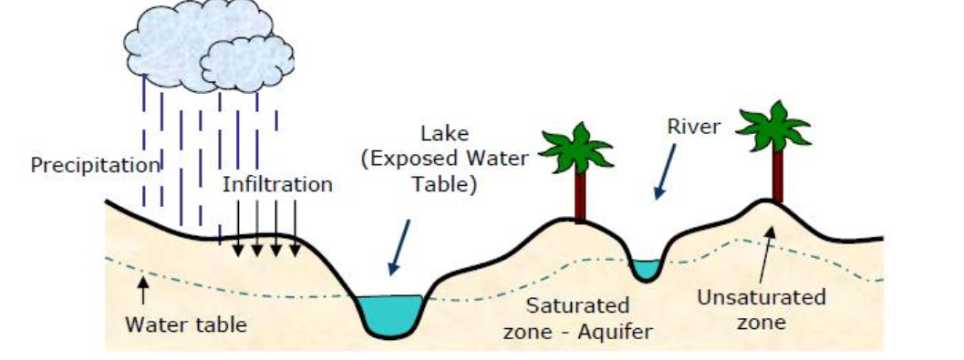

**Capillary Fringe**: region above the water table where water rises due to capillary forces in the porous medium.  
**Saturated Zone**: Phreatic Zone – rock and water.

**Water Table:**- Top of the saturated zone.  
- Depressed version of topography.  
- Surface waters are manifestations of the water table – exposed water table.  
**Aquifer**: a geologic unit that stores and transmits water.

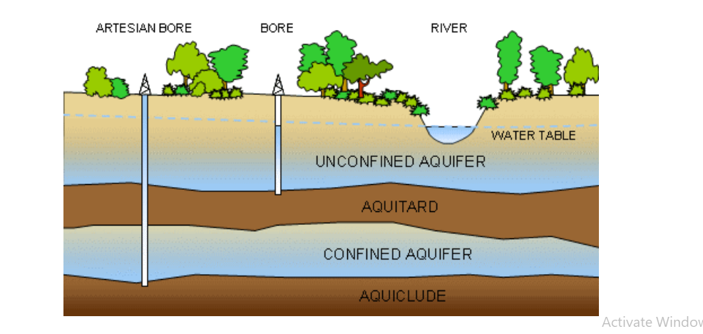

**What is the difference between a confined and a water-table (unconfined) aquifer?**❖ A **confined aquifer** is an aquifer below the land surface that is saturated with  
water. Layers of impermeable material are both above and below the aquifer,  
causing it to be under pressure so that when the aquifer is penetrated by a well, the  
water will rise above the top of the aquifer.  
❖ A confined aquifer is a recharge-up gradient that forces water to flow down and get  
trapped under an aquiclude. Water is under pressure due to the weight of the  
up gradient water and the confinement of the water between “impermeable” layers.  
*Water flows to the surface under artesian pressure in an Artesian well*.  
❖ A **water-table or unconfined, aquifer** is an aquifer whose upper water surface  
(water table) is at atmospheric pressure, and thus is able to rise and fall. Water table aquifers are usually closer to the Earth's surface than confined aquifers are,  
and as such are impacted by drought conditions sooner than confined aquifers.

**Aquifer contamination:**

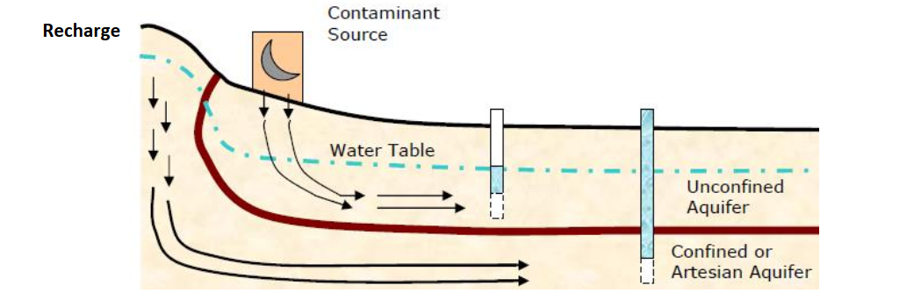

❖ Unconfined aquifers are used for water supply, they are often contaminated by  
wastes and chemicals at the surface.  
❖ Confined aquifers are less likely to be contaminated and thereby provide supplies  
of good quality.  
❖ Mechanisms of transport are advection and dispersion.  
❖ There can be chemical interactions in the aqueous phase or between the water and  
solid media.

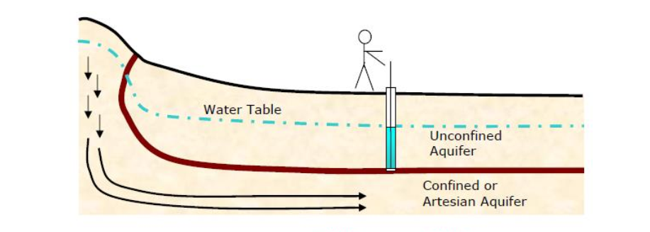

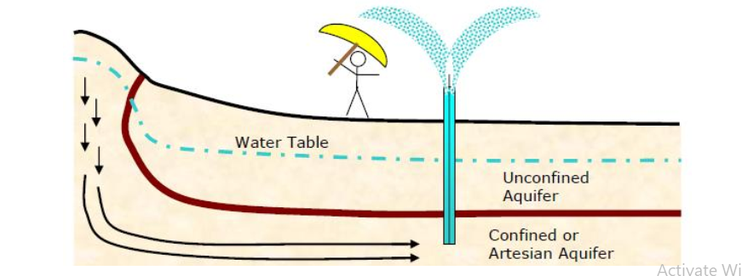

**Key Aquifer Properties:  
Porosity:** Percentage volume occupied by voids.  
**Permeability**: Measures the transmission property of the media and the interconnection  
of the pores. Related to hydraulic conductivity and transmissivity.  
**Darcy’s Law:**In 1856 in Dijon, France, Henry Darcy conducted his now-famous experiment of pouring  
water through sediment-packed pipes to see how much would flow through them in a  
given amount of time [volume of flow per unit time].  
Flow through the column is Q in L3/T**←** most important quantity  
The flow per unit area is a **specific discharge.**

$q=\frac{Q}{A} with units of velocity\frac{L}{T}$**called Darcian velocity or**

**Daecian flux, but not the actual velocity of the fluid**

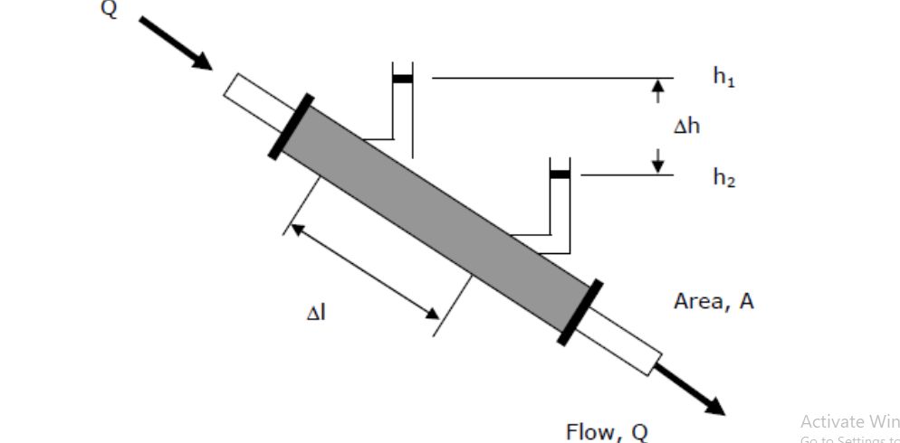

**Darcy showed that:**Q is in direction of decreasing head.  
q is proportional to h2 – h1 = Δh, given Δl fixed, q α (-Δh).  
q is inversely proportional to Δl, given Δh fixed, q α (1/Δl).  
The proportionality constant is K, and flow is from the higher to the lower hydraulic head.

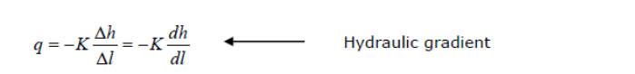

*K* is hydraulic conductivity and has units of velocity (L/T). It is a function of both media and fluid.

Q is a flow per unit cross-section and is **not** the actual velocity of groundwater flow. Δh represents the frictional energy loss due to flow through media.

Darcy’s law is a macroscopic law. It doesn’t tell you about the flow through individual pores. The discharge is Q in L3 /T

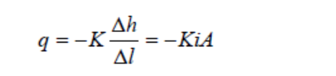

*i* is commonly used for gradient. Note the difference between Q and q.

**What is hydraulic conductivity?**

*K* is a property of both media and fluid.



***k*** = the intrinsic permeability (L2 ), a property of media only

**ρ** = the mass density (M/L3 )

**μ** = the dynamic viscosity (M/LT) and measures the resistance of a fluid to shearing that is necessary for flow

**Range of Applicability of Darcy’s Law** At extreme gradients some have questioned the applicability of Darcy’s Law (controversial)

Low Gradients.

- Compacted clays and low gradients.

- Threshold gradient to get flow.

-Below a certain gradient – nonlinear.

*High Gradients*

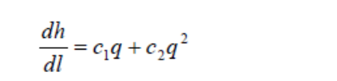

Term 1 is loss – viscous friction against wall of solids and

Term 2 is loss – dissipation of kinetic energy in pores – flow converges and diverges. Must have laminar flow within pores.

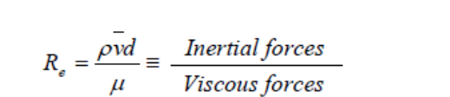

Laminar in pipes < 2,000 in rocks < 10

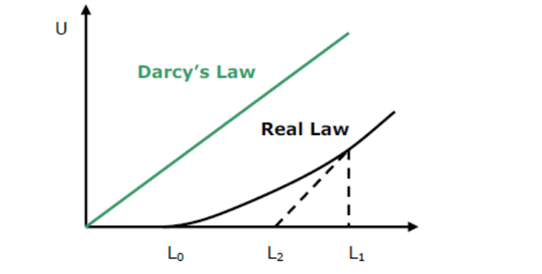

**Measures of hydraulic conductivity (L/T) :**

• Commonly cm/s, m/d, ft/d

• Older unit, gpd/ft 2 , or meinzer.

**Measures of permeability, (L2 ).**

❖ Often the **Darcy Unit** is used, to recall

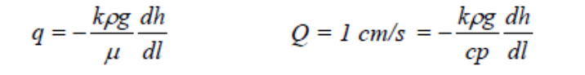

**1 darcy** is the permeability that gives a specific discharge of 1 cm/s for a fluid with a viscosity of 1 cp under a **hydraulic gradient times density times g of 1 atm/cm.**

- It equals about 10 -8 cm 2

- About 0.831 m/d at 20 C.

**Important** – A typical aquifer measure of the transmission property of media for the flow of water is given over a thickness, b

Transmissivity T= Kb [L2**∕** T]

- Very common quantity for the site and regional studies.

- Much more on this when we get to groundwater flow equation and well tests.

**Relations between Grain Size and Hydraulic Conductivity**

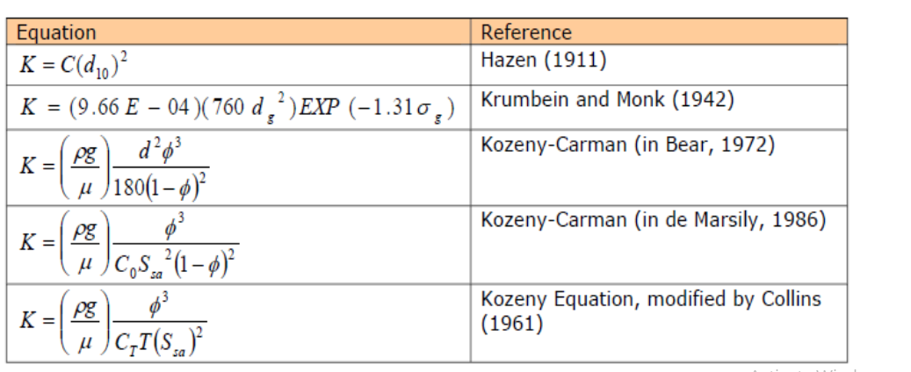

**C0**= factor reflecting pore shape and packing in the Kozeny-Carmen eqn. [-]

**CT**= factor reflecting pore shape and packing in Kozenyeqn, mod. By Collins [-] C= factor in the Hazen equation [T/L]

**d10**= grain diameter for which 10% of particles are smaller [L]

**dg**= geometric mean grain diameter [L]

**d** = representative grain diameter [L] **g** = gravitational acceleration [L/T2]

**K** = hydraulic conductivity [L/T]

φ = total porosity, accounting for compaction [-] μ = dynamic viscosity [M/LT]

ρ = density [M/L3]

σ**g**= geometric mean standard deviation [L]

**Ssa**= surface area exposed to fluid per unit volume of solid medium [1/L]

**T** = tortuosity [-]

Remember Darcian Velocity is not an actual velocity; it is discharged per unit area (the area is the TOTAL cross-section)

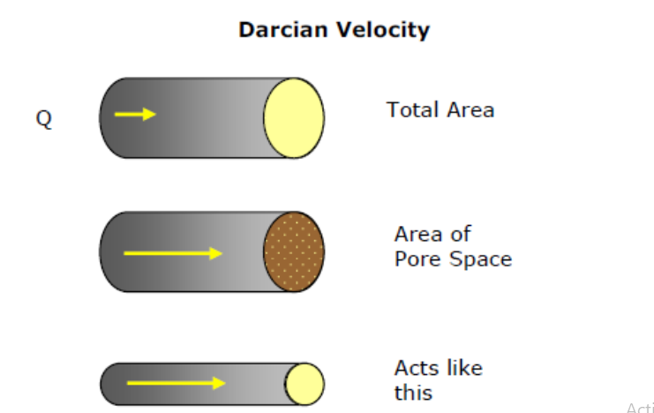

Average Linear Velocity

**Primary porosity:** the original interstices**.**

**Secondary porosity:** secondary dissolution or structural openings (fractures, faults, and openings along bedding planes).

**Computed porosity:** n = 100[1-ρb/ρp]

ρb= bulk density( M/L3 )= mass of dry sample/original volume.

ρp = particle density (M/L3 )= mass of dry sample/volume of mineral matter from the water-displacement test (2.65 g/cc).

**Effective porosity**: porosity available for flow, ne

Can have isolated water as dead-end pores or trapped gas. IMPORTANT to transport.

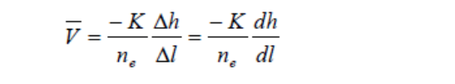

*V* is the average linear pore water velocity. The measure of the rate of advection of a slug of water. *V* is larger than the Darcian Velocity.

*q = ne V*

**Hydraulic Head and Fluid Potential**

**Potential:**

A physical quantity is capable of measurement at every point in a flow system, whose properties are such that flow always occurs from regions in which the quantity has less high values to those in which it has lower values regardless of the direction in space.

Examples: Heat conducts from high temperature to low temperature • Temperature is a potential

Electricity flows from high voltage to low voltage • Voltage is a potential

**Fluid potential and hydraulic head**

Fluids flow from high to low fluid potential

❖ Flow direction is away from the location where mechanical energy per unit mass of fluid is high to where it is low.

❖ How does this relate to measurable quantity?

- Groundwater flow is a **mechanical process** – forces driving fluid must

overcome frictional forces between porous media and fluid. (generates thermal

energy).

- Work is the mechanical energy per unit mass required to move a fluid from point

z to z’

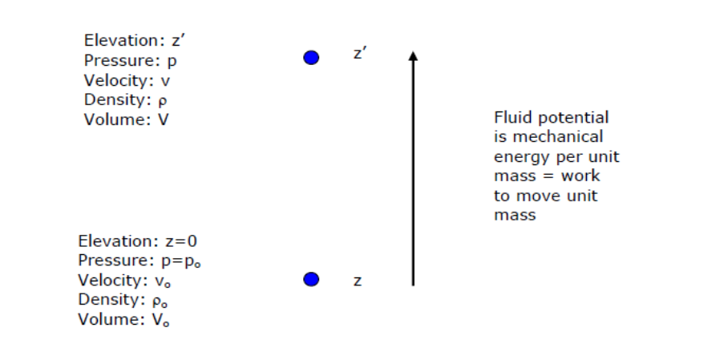

**The fluid potential** is the mechanical energy per unit mass of fluid potential at z’ = fluid potential at datum + work from z to z’. The work to move a unit mass of water has three components:

1. Work to lift the mass (where z = 0)
$$w_{1}=mgz^{∙}$$

2. Work to accelerate fluid from *v*=0 to *v*’.

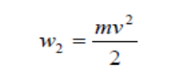

1. Work to raise fluid pressure from p=po to p.

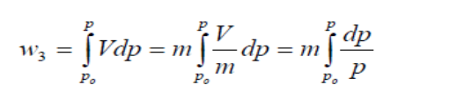

Note that a unit mass of fluid occupies a volume *V* = 1/ρ

**The Fluid Potential (**the mechanical energy per unit mass, m=1**)** is:

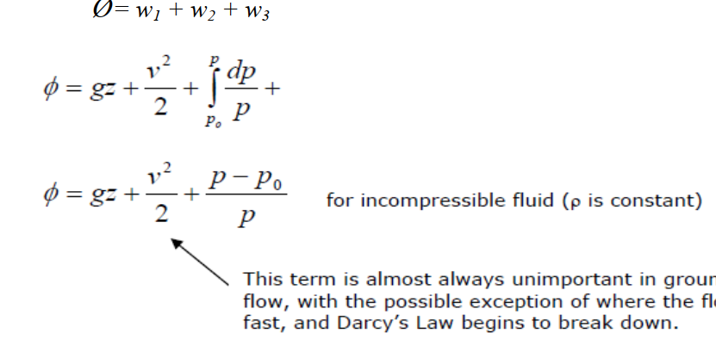

How does potential relation to the level in a pipe? At a measurement, point pressure is described by:

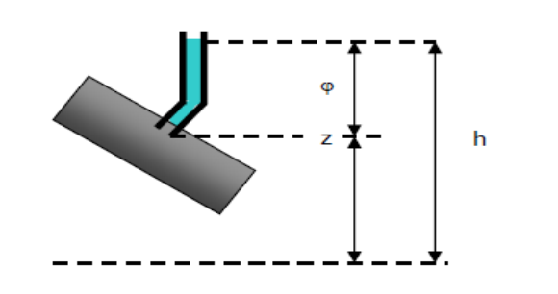

$$P=ρg \left(depth\right)+P_{o}$$

$$P=ρg ∅+P_{o}$$

$$P=ρg(h-z)+P_{o}$$

h = hydraulic head. z = elevation head.

ϕ = pressure head (depth).

Return to fluid potential equation:

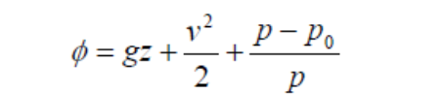

Neglect velocity (kinetic) term (*v*2/2) , and substitute for *p*

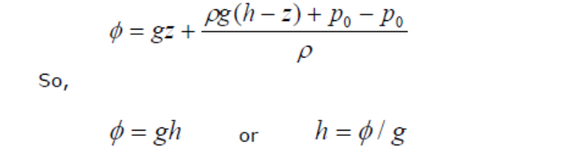

**Heterogeneity and Anisotropy:**

-Hydrologic properties (hydraulic conductivity *K*, specific storage *S*, etc.) may vary through space within a geological formation.

- The spatial variation of hydraulic properties is called ***heterogeneity****.*

- This unit is homogeneous if the geologic unit has the same hydrologic properties at all locations.

- Hydrologic properties may also change with the direction of measurement at any given point within a geologic formation. This dependence of hydrologic properties on the direction of measurement is termed ***anisotropy***.

- On small scales, the cause of anisotropy is the shape and orientation of minerals in

- If the geologic unit has the same hydrologic properties at all directions, this unit is ***isotropic***.

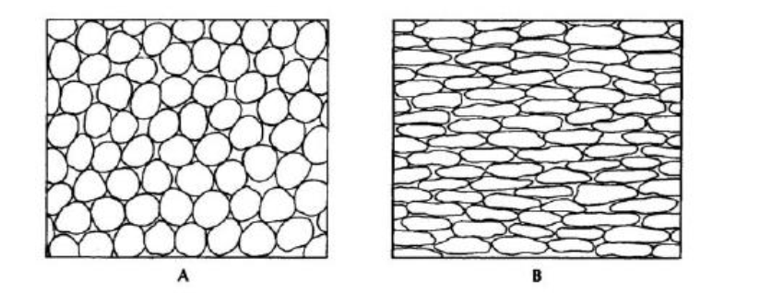

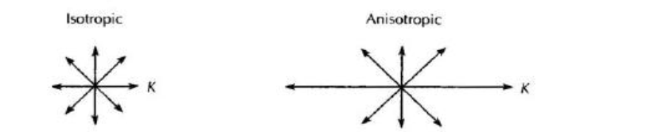

Grain shape and orientation can affect the isotropy and anisotropy of sediment.

As mentioned earlier, there is a relationship between layered structure and anisotropy. Let us consider the layered formation shown in the Figure below. Each layer is homogeneous and isotropic with hydraulic conductivity values of K1, K2, ..., Kn. First, let us examine the case where flow is perpendicular to the layered structure. The discharge Q must be the same entering each layer as it is leaving. Let Δh1 be the head loss across the first layer, Δh2 across the second layer, and so on. The total head loss across the whole layered structure is then Δh = Δh1 + Δh2 + ... + Δhn

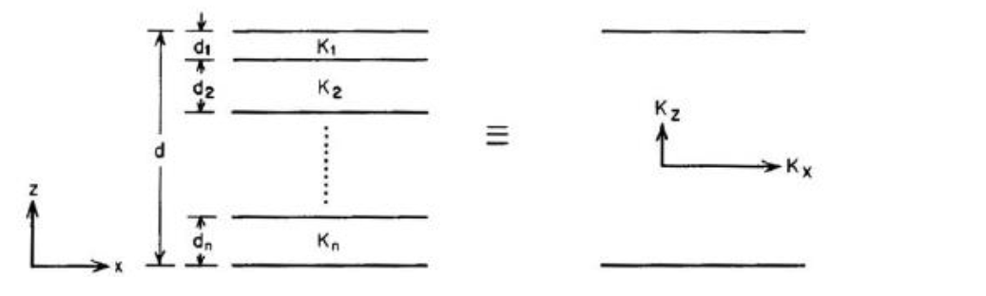

Relation between layered heterogeneity and anisotropy.

From Darcy’s law, we have

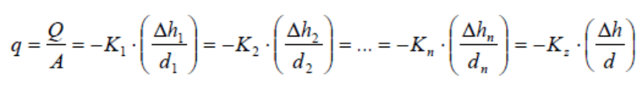where *q* is **specific discharge**, *A* is the vertical cross-sectional area, *K z* is an **equivalent vertical hydraulic conductivity** for the whole layered structure, *di* is the thickness of the ith layer (i = 1, 2, …, n) and *d* is the overall thickness of the layered structure (Figure above). From equation (A) we have:

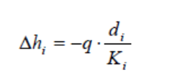

where *i* ranges from 1 to *n*, and

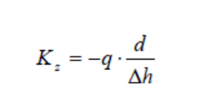

Substituting equation B into equation C gives

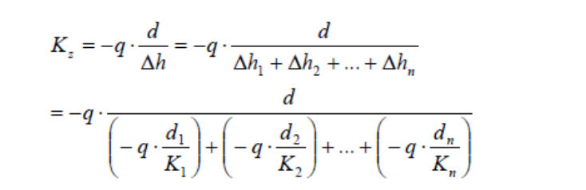

Canceling –q gives:

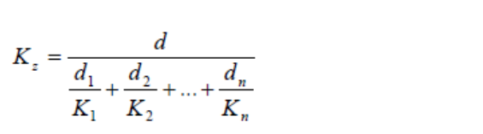

Now let us consider the case where flow is parallel to the layering. Let Δh be the head loss over a horizontal distance l. The discharge Q through the layered structure is the sum of the discharges through the individual layers (Q1, Q2, ..., Qn). If the thickness of the layered structure is 1 (unit thickness), then the cross-sectional area (perpendicular to the horizontal flow) for each layer, Ai, is, where i ranges from 1 to n.

From Darcy’s law we have

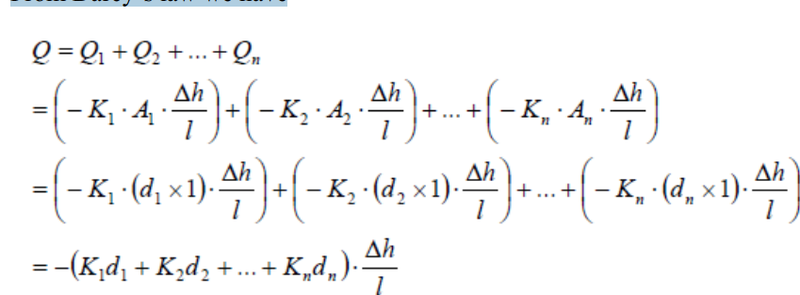

If the **equivalent horizontal hydraulic conductivity** of the layered structure is K x , then from Darcy’s law we have

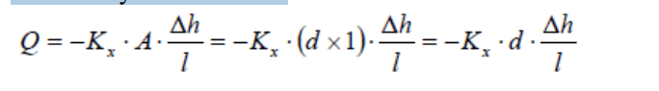

Equating F and G and rearranging, we have

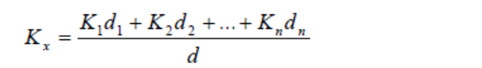

Equations E and H provide the K x and K z values for a single homogeneous but anisotropic formation that is hydraulically equivalent to the layered structure of homogeneous, isotropic geological formations illustrated in Figure. It can be mathematically proven that K x > K z for all possible K1, K2, …, Kn values. For example, for a simple layered system having two layers of identical thickness with K1 = 10 -1 cm/s (gravel) and K2 = 10 -4 cm/s (fine sand), the ratio of K x /K z is 250.